

**Java Institute for Advanced Technology**

Web Engineering II

HF2L

Assignment 01

K.D.I.V Vimukthi

177646148

960263812v

Colombo



# Introduction

The number of online shoppers has quadrupled in recent years. It is not easy to hire and hungry, two uncontrollable growth of online shoppers alcohol. "(Techgenuine, 2017)  
There are many other components to create a Web e-commerce web applications. Websites vary according to the type of site and the concept of electronic commerce.

# Responsiveness through all devices

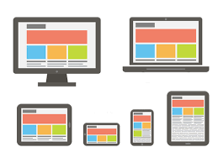

## Responsive Design

A responsive website is one that responds (or changes) based on the needs of the users and the device (mobile device in this example) that they're viewing it on. Here, text and images change from a three-column layout to a single column display. Unnecessary images are hidden so they don’t interfere or compete with the more important information on the site's smaller display.

If you are on a computer, you can tell if a site is responsive by reducing your browser’s window size from the full screen down to very small. If the appearance of the text, images, and menu change as you get smaller, the site is responsive.:

* Dynamic content that changes
* Navigation is condensed
* Optimized images
* Correct padding and spacing
* Reliant on mobile operating systems to function

# Search Tool

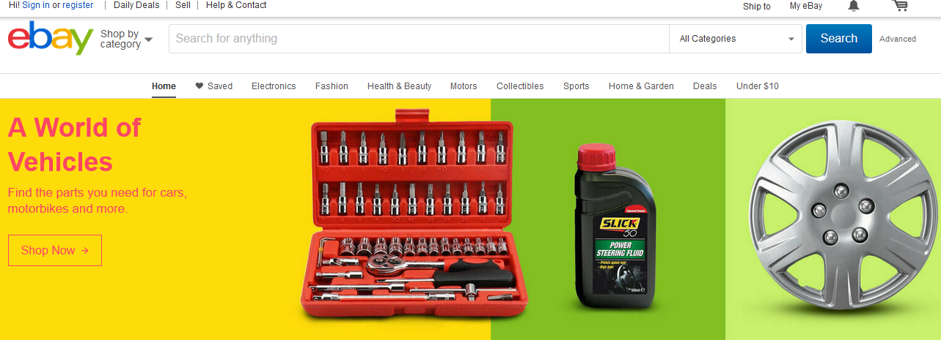

A visitor for the first time is probably looking for a particular thing. They don't want to spend all day reviewing items they don't need. Filtered searches are an important product and should be present if you want to make sure you get the best result.   
There are several ways for you to **find** the **item** number (also called "**Item** #"): The **item** number appears on the top right corner of the listing. In My **eBay**, click the Purchase History link on the left side of the page. You'll see the **item** number in parentheses at the end of the listing title.  
The search box is a very important component if there is a large store that has a wide variety of products. The customer must have the ability to search for the product they want. It gives an attraction to the web application and saves customer time.

# Product Information and Images

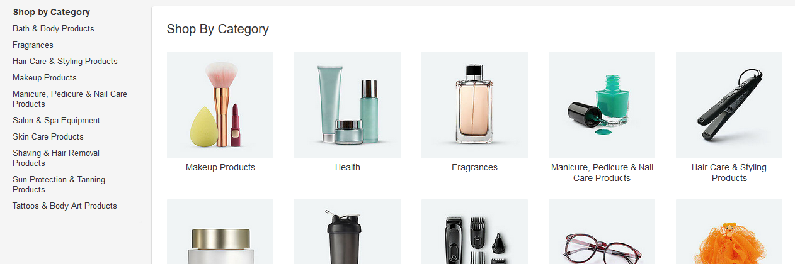

In Mauris door industry, the user will need to be God's image. If the image looks good, the chances are very high and selling product. So the overall design of your website with quality images constantly uploaded to the website. At least 4-5 you can include images of a product that interested buyers from different angles. And it easier to zoom view images of the results are simply better user experience. "(Techgenuine, 2017)  
  
There is another important component in a web application. Then, when it is clear from the pictures and brief product description it will increase the attraction of buyers and may increase it. But this time there is no clear description of the product to which it is needed.  
send feedback

# Shopping Cart



““An e-commerce site doesn’t need a shopping cart to process transactions, but many site owners add shopping cart and checkout icons to their sites. As site visitors choose items to purchase, they have the option to “place them in their carts.”” (Lee, 2017)

A **shopping cart** is a software used in eCommerce to assist visitors to make purchases online. Upon checkout, the software calculates the total of the order, including shipping and handling, taxes and other parameters the owner of the site has previously set.

Shopping cart is an essential web component used in an ecommerce web application. All the items that client buys are placed in the shopping cart as in the real world. They can purchase all the items in the shopping cart all at once. It saves the time of the client.

**Add to Cart** is a way to create a temporary list of items by adding them to your **cart**, which will keep track of the items until you leave our website. You can export items in your **cart** by saving the list to a file or sending it to an email address. You can also place the items on hold or **add** them to your wish list.

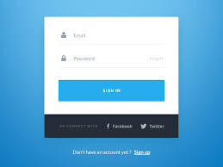

“An ecommerce site might allow a user to shop without login to system. But at times it is desirable to let user create a profile, so that he does not need to enter his details (address, name, phone number etc.) every time he makes a purchase.”

It’s another very important component use in ecommerce web application. From that customer can manage a profile. Can get offers, discounts and other benefits when the client is a user at the web application.

# Feedback and Customer Service



What is **customer feedback**. **Customer feedback** is information provided by clients about whether they are satisfied or dissatisfied with a product or **service** and about general experience they had with a company. Their opinion is a resource for improving **customer** experience and adjusting your actions to their needs.

It is the most important component in real world as well as in web applications, getting a customer feedback is very important. Client should have the ability to inform the issues, suggestions, and any other complaints regarding the product issued by the web application.

Use **customer feedback** to **improve** your existing products and **services**. ... If **feedback** shows **customers** are frustrated with email response times, **improve** them. If **feedback** shows **customers** want another channel of communication – open one. Your **customers** make or break your business, so **do** your best to give them what they want.

# Payment System



“Online stores commonly use credit and debit cards, gift vouchers, cash on delivery, PayPal, etc. as their main payment system.” (Davlin, 2017)

Payment system is another web component use in ecommerce web application. Different web applications have different methods or their own method for payment system to deal with all over the world. Some web applications do not accept credit cards. Others require the client billing address and the delivery address to be in the same country as the official store’s location

# Simplicity

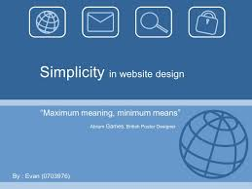

implicity in website design doesn’t necessarily equate with a minimalist design aesthetic. Simple sites just remove all unnecessary elements from the design, content, and code. While minimalist sites generally fit this criteria, there are plenty of sites that wouldn’t, by any stretch of the imagination, be considered “minimalist” that still fit the definition of simple.No one is like to read a manual and able to use the web application. They want clear and understandable application. Client want like to spend their time by reading along description about the application and it make the web site less attractive.

# Social Media Links

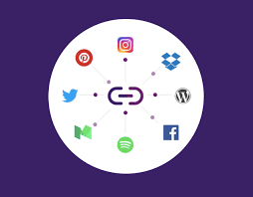

A **social media** share **link** is a URL that when clicked populates a set message and image that can be shared on **social media**. They are useful for amplifying your message and minimizing the time it takes someone to compose a **social media** message about your content.

“It’s said that almost 20% of online purchases are accomplished after surfing through social media sites. People are inclined to take in public opinion. Social media websites, such as Facebook and Twitter, are the best, if not fastest, source to get the info you need on just about everything” (Davlin, 2017)

You can also **add** the **social** icon menu in your **WordPress** sidebar. Simply go to Appearance » Widgets page and drag the 'Navigation Menu' widget in the sidebar widget area. In the Select Menu dropdown, you should select the **social** menu that you created above and click on the 'Save' button

Now a days social media play a big role in the ecommerce world. It bring excellent opportunities for self-promoting. We can find anything through social media links by browsing them.